**Module 2 Kinematics of particles**

**Curvilinear Motion**

1. P at the end of the telescoping rod in Fig slides along the fixed parabolic path y2 = 40x, where x and y are measured in millimeters. The y coordinate of P varies with time t (measured in seconds) according to y = 4t² + 6t mm. When y = 30 mm, compute (a) the velocity vector of P (b) the acceleration vector of P.

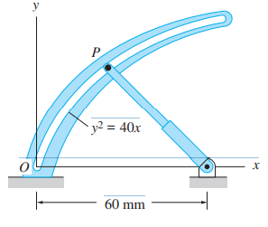

2. At any instant the horizontal position of the weather balloon in Fig is defined by x = (8t) m, where t is in seconds. If the equation of the path is y = x²/10, determine the magnitude and direction of the velocity and the acceleration when t = 2 s.

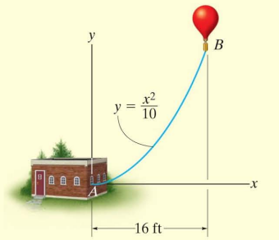

3. For a short time, the path of the plane in Fig. is described by y = (0.001x²) m. If the plane is rising with a constant velocity of 10 m/s, determine the magnitudes of the velocity and acceleration of the plane when it is at y = 100 m.

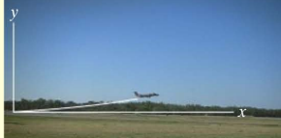

4. A particle is traveling along the parabolic path y = 0.25x² .If x = (2t² ) m, where t is in seconds, determine the magnitude of the particle's velocity and acceleration when t = 2 s.

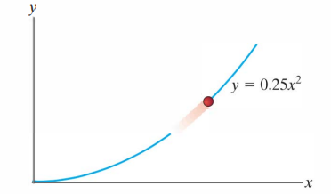

5. If the x and y components of a particle's velocity are Vx = (32t) m/s and Vy = 8 m/s, determine the equation of the path y = f(x). x = 0 and y = 0 when t = 0.

6. A particle travels along the path y²= 4x with a constant speed of v = 4 m/s. Determine the x and y components of the particle's velocity and acceleration when the particle is at x = 4 m.

7. A particle is projected from the ground at 50 m/s at an angle of tan-1(4/3) to the horizontal. Determine the tangential and normal component accelerations of the particle 1.5 sec. after the throw. Also determine the radius of curvature of the path then. State when and where the radius of curvature of the path is minimum and find its magnitude.

8. A particle moves along a hyperbolic path x²/16 - y² = 28. If the x - component of velocity is Vx = 4 m/s and remains constant, determine the magnitudes of particle’s velocity and acceleration when it is at point (32 m, 6 m).

9. A particle moves on a circular path with its position from rest defined by S = t3 + 5 t, where the arc length s and time t are measured in meter and second respectively. It is observed that at t = 0.66 seconds the magnitude of the acceleration is 8.39 m/s². What is the diameter of the path.

10. A Particle moves in the X – Y plane with velocity components, Vx = 8t -2 & Vy = 2. If it passes through the point (x,y) = (14,4) at t = 2 seconds, find the equation of the path traced by the particle. Also find resultant acceleration at t = 2 seconds